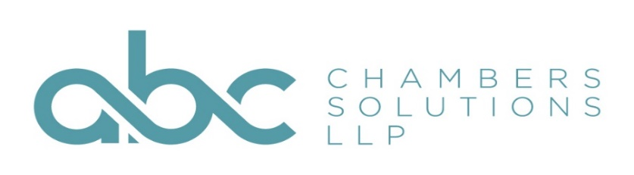

Annual Charity Golf Day Monday 28th June 2021
‘Raise your clubs to raise some money’
In aid of
Advocate - The Pro Bono Charity of the Bar
Venue: Bishop’s Stortford Golf Club - home of the Eastern Region of the PGA
£375 for 4 ball team to include:
Hole sponsorship – promoting your Chamber’s logo on the tee
Promotion of your Chamber’s support for the event via ABC & Advocate social media
Tea/coffee and bacon roll on arrival
Use of practice facilities including free driving range balls
18 holes of golf (c9:30 tees)
Delicious 2 course carvery meal
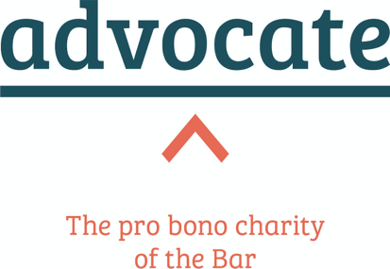
Prizes for best team, individual score, longest drive and nearest the pin
Charity raffle with a range of quality prizes

Limited single player places available at £90 per player
To book your place please email bill@abcllp.com
An invoice will be raised, with confirmation of booking upon receipt of payment.

